Name: k.janani
Reg No: 192511243
EXP NO 4:
DATE: 06/08/2026

CREATE A SIMPLE CLOUD SOFTWARE APPLICATION FOR CAR BOOKING RESERVATION SYSTEM USING ANY CLOUD SERVICE PROVIDER TO DEMONSTRATE SAAS.
AIM:
To Create a simple cloud software application for Car Booking Reservation System using any Cloud Service Provider to demonstrate SaaS.
PROCEDURE:
step1: Go to zoho.com.
step 2: Log into the zoho.com.
step 3: Select one application step.
step4: Enter application name as Car Booking Reservation System.
step 5: Created new application as Car Booking Reservation System.
step 6: Select one form
step 7: The software has been created.

IMPLEMENTATION:
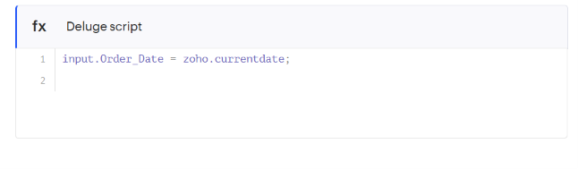
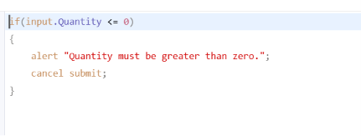
Output

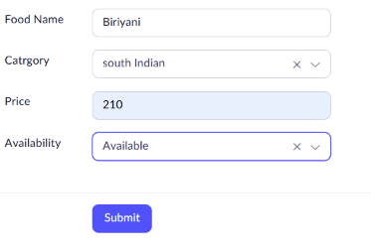
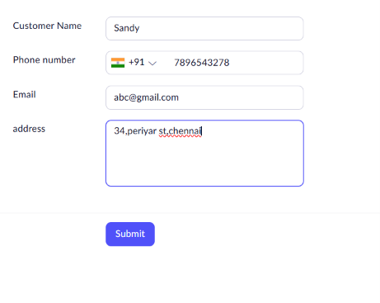

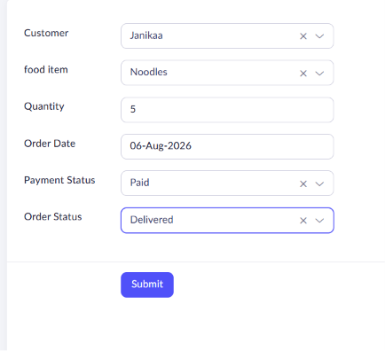

Result
The Online Food Ordering System was successfully developed using Zoho Creator. The application allows customers to view food items, place orders, and manage order details through a cloud-based platform, successfully demonstrating the Software as a Service (SaaS) model.

